SEGMENTATION USING CUSTOMERTS LIFETIME VALUE: HYBRID K-MEANS AND ANALYTIC HIERARCHY PROCESS SPACE)

THESIS

In partial fulfilment of the requirements

for the Degree of Master of Science in Management

from Institut Teknologi Bandung

By

Radit Rahmadhan

Student ID: 29020003

(Master Program of Science in Management)



INSTITUT TEKNOLOGI BANDUNG  
2022

ABSTRACT

TITLE OF THESIS IN ENGLISH: TYPE OF LETTER (FONT) TIMES NEW ROMAN; CAPITAL LETTER (SIZE 14); BOLD; SINGLE SPACE

By

Student Name

Student ID: 29000001

(Master Program of Science in Management)

Write abstract in English here. The font size in the abstract is 12, times new roman characters and not written in bold. Abstract consists of 500-800 words. The first sentence of the abstract is three spaces from the last line of the name of study program. The first word or the beginning of a new paragraph should be separated by a single space from the last sentence of the preceding paragraph. Abstracts are written in English and consist of 500-800 words. The end of abstract, which is still in the sheet of this abstract but in separate line from abstract, ended with keyword (keywords). Keywords (keywords) written at the bottom of the abstract are words, which are related and derived from the abstract. **IT SHOULD NOT BE** derived / taken from the body/ text of the thesis. The minimum numbers of keywords are 4 single words or a single meaningful two-word combination and maximum number of keywords are 7 single words or a single meaningful two-word combination.

The proposed research contained in the abstract should comprehensively carried out the research problems, which explaining reasons why the scientific issues need to be studied; the background; the research stages; the assumptions and hypotheses that need to be proved; as well as the research objectives to be achieved; the method used; the brief review; and the explanation of the results that will be obtained in the study. The contribution of the research results to the science should be clearly stated. Abstract pages and the preparation section of the thesis should be separately numbered from the main body page number of the thesis. The preparatory pages are numbered by using Roman numerals i, ii, iii, iv, …, x, xi, ... to distinguish it from the main body page numbers of the of thesis in the form of Arabic numerals.

Keywords: keyword 1, keyword 2, etc.

Note: The term "1 space" refers to a single enter key used with the same typeface format, while the size of each space is indicated by the term "space 1" or "space 1.5".

ABSTRAK

*WRITE THE TITLE OF YOUR THESIS IN BAHASA INDONESIA HERE (TIMES NEW ROMAN, ALL IN CAPITAL LETTER, FONT SIZE 14 IN ITALIC, BOLD, SINGLE SPACE)*

*Oleh*

Student Name

Student ID

*(Program Studi Magister Sains Manajemen)*

*Write abstract in Bahasa Indonesia here. The font size is 12 and not bold. The first sentence of the abstract should be 3 spaces away from the last line of the program name. The abstract content, which is an Indonesian translation of the abstract in English language, is printed in size 1; not bold; and in italic form. The first word or the beginning of a new paragraph is separated by a single space from the last sentence of the preceding paragraph. Abstract are written in Indonesian and consist of 500-800 words. The end of abstract, which is still in the sheet of this abstract but in separate line from abstract, ended with keyword. Keywords written at the bottom the abstract are words which are related and derived from the abstract, and* ***SHOULD NOT BE*** *derived / taken from the body / text thesis. The minimum numbers of keywords are 4 single words or a single meaningful two-word combination and maximum number of keywords are 7 single words or a single meaningful two-word combination.*

Keywords: kata kunci 1, kata kunci 2, dst.

Note:

Footnote writing format should be removed and not allowed in thesis.

1. Thesis should be written on the computer on both sides of the paper page. Therefore, use the mirror margins facility available in Word Processor. Thus, the limit for the odd pages for both the left edge and top edge are 4 cm; right edge and the lower edge each 3 cm. Meanwhile for even pages, the left edge and top edge is 3 cm, whereas right edge 4 cm, and the bottom edge 3 cm.
2. Deviation from point 1 may be made for thesus documents that are before the binding with hard cover of less than 1.5 cm thick (less than ± 115 sheets).
3. This template refers to point 2, while the template referring to point 1 can be found by <http://www.sps.itb.ac.id>.

SEGMENTATION USING CUSTOMERTS LIFETIME VALUE: HYBRID K-MEANS AND ANALYTIC HIERARCHY PROCESS

HALAMAN PENGESAHAN

By

Radit Rahmadhan

Student ID: 29020003

Master Program of Science in Management

Institut Teknologi Bandung

Approved

December

Supervisor

______________________

(Meditya Wasesa, S.T., M.Sc., Ph.D.)

THE GUIDANCE FOR USING THE THESIS

Unpublished masters’ thesis is registered and available in the Library of Bandung Institut of Technology, and is open for public, provided that the author owns the copyright in accordance with the intellectual property rights that are applicable in the Library of Institut Teknologi Bandung. Bibliographical references are allowed to be use in a limited manner, however the citation and summarization can only be proceed upon the author’s permission and must include the scientific norm of stating this thesis as the source.

This thesis has to be cited as:

Rahmadhan, Radit. (2022): *Segmentation using Customers Lifetime Value: Hybrid K-Means Clustering and Analytic Hierarchy Process*, Masters’ Thesis, Institut Teknologi Bandung.

Reproduction or publication of parts or whole of the thesis must be under the consent of the Head of Graduate School, Bandung Institute of Technology.

HALAMAN PERUNTUKAN

*In dedication to my beloved parents, brothers, and family, supervisor and advisor, and friends who always support me.*

# 

# STATEMENT OF AUTHORSHIP

I hereby declare that I am the sole author of this thesis and to the best of my knowledge and belief, the thesis contains no material previously published or written by another person except where due reference is made. I further declare that this thesis has not been previously submitted to obtain a degree at this or any other higher education institution.

Signature:

Bandung, December 20,2022

# ACKNOWLEDGEMENTS

The introduction page is printed on a new page. On this page, the Masters’ students may have the opportunity to express their gratitude in writing to other mentors and or individuals who have provided guidance; advise and critics; as well as to those who have assisted in conducting the research; whether individuals or bodies that have provided financial assistance, and so forth.

In the forewords, authors may use all kinds of writing varieties. However it is advisable to keep it in a standard written sentences. Acknowledgments should be made in excessive and limited only to the "scientifically related".

TABLE OF CONTENTS

ABSTRACT i

ABSTRAK iii

VALIDATION PAGE v

THE GUIDANCE FOR USING THE THESIS vii

DEDICATION PAGE ix

STATEMENT OF AUTHORSHIP xi

ACKNOWLEDGEMENTS xiii

TABLE OF CONTENTS xiv

LIST OF APPENDICES xv

LIST OF FIGURES xvii

LIST OF TABLES xix

LIST OF ABBREVIATIONS AND SYMBOLS xx

Chapter I Introduction 1

I.1 How to Write Background 2

I.2 How to Write References 2

Chapter II Literature Review 4

Chapter III Research Methodology 7

III.1 Please write down the title of subchapter 7

Chapter IV Results and Analysis 11

IV.1 Example of Writing Subchapter Which Consists Words of More than One Line 11

IV.1.1 Example of Numbering and Locating Title of Sub subchapter 11

IV.1.2 Example of Numbering and Locating Title of Sub subchapter 11

IV.1.3 Example of Numbering and Locating Title of Sub subchapter 11

Chapter V Summary and Conclusion 15

REFERENCES 17

APPENDICES 21

Catatan: Ukuran huruf 12, dengan ukuran spasi 1, dan tidak tebal. Halaman daftar isi terdiri atas satu halaman atau lebih. Daftar isi sebaiknya bukan diketik, tetapi dibangkitkan dengan memakai fasilitas yang tersedia pada *Word Processor* dengan memanggil *style* Judul Bab, Judul Bab Miring, Judul Bab 1.5, Judul Bab Sub1, Judul Bab Sub2 dan Judul Bab Sub3. Setelah dibangkitkan dilakukan perapihan format seperti contoh.

LIST OF APPENDICES

Appendix A Example of Approval Page Contains Two Supervisors 23

Appendix E Example of Margin for Even Pages (if the Thesis Document is Printed on Both Sides) 28

Appendix F Example of Thesis Cover and Binding 29

Catatan: The List of Appendices contains one page or more. The List of Appendices is preferably be automatically formatted by the Word Processor by using the function of Style for Reference and Subtle Reference. Henceforth, it should be formatted as the example provided above.

LIST OF FIGURES

Figure III.1 Example of the title of the figure that has several parts (a) the first subfigure title, (b) the second subfigure title, and (c) the third subfigure title. 8

Figure IV.2 The separation of two dimensions of phospholipid essence from human erythrocytes. Solvent: chloroform – metanol – light oil – wáter (8: 8: 6: 1) in the first dimensión and aceton – chloroform – metanol – wáter (8: 6: 2: 2: 1) in the second dimensión (Last name of autor, Year). 13

Note: The List of Figures and Illustrations contains one page or more. The List of Figures and Illustrations is preferably be automatically formatted by the Word Processor by using the function of Style for Figure. Henceforth, it should be formatted as the example provided above.

LIST OF TABLES

Table III.1 Example of writing format of table: Objective function value 6

Table III.2 Example of writing format of table: The condition of rice in North Sumatra in 3 years (1969-1971) (Last name of author, Year)* 6

Note: The List of Tables contains one page or more. The List of Tables is preferably be automatically formatted by the Word Processor by using the function of Style for Table. Henceforth, it should be formatted as the provided example above.

LIST OF ABBREVIATIONS AND SYMBOLS

|  |  |  |
| --- | --- | --- |
| ABREVIATIONS | Name | Page of initial usage |
| AMR | Adaptive Mesh Refinement |  |
| CT | Computed Tomography |  |
| DSV | Singular value decomposition |  |
| HPLC | High Performance Liquid Chromatography | 10 |
| MEH | Finite element method |  |
| MEHA | Adaptive Finite Element Method |  |
| NMR | Nuclear Magnetic Resonance | 10 |
| PCR | Polymerase Chain Reaction | 10 |
| RCBM | Model-Based Image Reconstruction |  |
| Tm | Terameter |  |
| TO | *Optical Tomography* |  |
| TOF | *Fluorescence Optical Tomography* |  |

|  |  |  |
| --- | --- | --- |
| SYMBOLS | Name | Page of initial usage |
| A | Constant on tension relationship |  |
| A1 | Symbol Example |  |
| Ao | Amplitude of exit light signal |  |
| Ai | Amplitude of entry light signal |  |
| *a* | Photon on one element’s Density Vector |  |
| *a1* | Speed |  |
| *a1j* | Variable Reaction Function in differential |  |
|  | Equation coefficient |  |
| *b* | Wave propagation basic equation |  |
| *c* | The Speed of Light |  |
| *c0* | Specific body force |  |
| *f* | The probability density function |  |
| Ih | The irradiance of scattering light |  |
| Im | The irradiance of incident light |  |
| *L* | The radiance |  |
| *N* | Node number |  |
| *n* | Light spread area’s form variable |  |
| n1 | The refractive index of the medium |  |
| n2 | The refractive index of the object |  |
| n | Normal field vector against αΩ field |  |
| Q | The photon power injected per unit volume |  |
| *r* | Position |  |
| SYMBOLS | Name | Page of initial usage |
| Ŝn-1 | Light spread area |  |
| ŝ | Light-emitting areas | 5 |
| t | Time | 5 |
| *α* | The angle between the incident and scattered light | 5 |
| *α1* | First interal variable |  |
| *α2* | Second interal variable |  |
| δ | Viscosity coefficient |  |
| θa | The angle between the incident propagation direction and the normal to the interface |  |
| θb | The angle between the refracted propagation direction and the normal to the interface |  |
| λ | Wavelength |  |
| μa | The absorption coefficient | 5 |
| μs | The scattering coefficient | 5 |
| Ω | The domain object | 5 |

Notes: Due to the nonexistence of the abbreviations and symbol in the thesis draft templates, not all of the examples of list of abbreviation and symbol above are given the page number. Therefore, inside the thesis draft all abbreviations and symbols used must be written in this list. The abbreviation and symbol list pages are written on a new page. The line of words on the abbreviation list page and the symbol are spaced apart. This page contains abbreviations of terms, units and symbols of variables / numbers (written in the first column), variable names and full name names written on the back of the emblem and abbreviation (written in the second column), and the page number where the symbolic abbreviation appears for the first time written in the third column).

The abbreviations and symbols in the first column are sorted in Latin alphabet. Capital letters followed by their lowercase letters and then followed by symbols written in Greek letters that are also sorted according to the Greek alphabet. The variable name/ quantity or the name of the term in the second column is written in lowercase; except the first letter, which should be written in capital letter

Chapter I Introduction

Write the opening pharagraph here (if any). The chapter title of the introduction (size 14, bold), written in lowercase except the first letter, is printed parallel to Chapter I without the full stop at the end of the last letter and placed symmetrically (centered) on the page. The main body of the proposed research consists of the introduction, which is the first chapter; the literature review, which is the chapter of the main content chapter of the research proposal; including the research schedule as well as the novelty and originality.

The introductory chapter, or chapter I, contains at least (details in sub chapters) the following:

**I.1 Background**

[This section explains the background, motivation (the importance of this research topic supporting by facts/evidence/phenomenon and expected contributions), and a summary of past literature review which will lead to Section I.2 and I.3]

**I.2 Research objectives**

[This section states the purpose/objectives of the research]

**I.3 Research questions**

[This section briefly explains research approach and methods that are going to be used in this study]

**I.4 Research approach and methods**

[This section briefly explains research approach and methods that are going to be used in this study]

**I.5 Key assumptions and research limitations**

[This section explains key assumptions and possible research limitations]

**I.6 Writing structure**

[This section explains what will be described or explored in next chapter]

I.1 How to Write Background

The paragraphs on the thesis do not contain indentations. Therefore, the first letter of the new paragraph starts from the left margin of the script. Put **a blank line** of 1.5 spaces and 12-letter size to separate the first line of the new paragraph from the last line of the preceding paragraph.

Do not start a new paragraph on the bottom of the page unless there is enough space for at least two lines. The last line of a paragraph should not be placed on the next new page. Leave the last line at the bottom of the current page. Otherwise, you should have to edit the paragraph to fit in the same page. Paragraph should contains one main idea / thought that composed of several sentences. Therefore, **avoid paragraph that consists only one sentence.**

I.2 How to Write References

For more than two writers / authors, the first author's name is written, followed by **et al**., then the year of publication. For example "Kramer et al. (2005) states that hominid tooth fossils have been found by his team in Ciamis. They are the first hominid fossils found in West Java". Moreover, it is acceptable to paraphrase sentences as it can also be written first followed by the citations (Name of Author, Year).

All references listed must be properly referred in the thesis text, vice versa. The use of footnotes to indicate referrals is strongly discouraged as it has to be described in the thesis text.

How to write references on sentences that are adapted, are as follows

References written by **1 person**: "(Hill, 2007)"

References written by **more than two people**, accompanied by the referenced page number of the book: "(Baker et al., 1998: 23-25)"

1 reference written by two people: "(Gao and Zhao, 2009)"

2 references with different number of authors: "(Hill, 2007 and Krammer et al., 2005)"

2 references that are written by more than 2 persons: "(Kramer et al, 2005 and Kumai et al., 1985)"

2 references that are written by the same main author, but published at different times: "(Culver et al., 2003a and 2003b)"

More than 2 references: "(Hill, 2007; Kramer et al., 2005; Gao and Zhao, 2009)"

How to write references in the sentence: ".... research results of Wijaya (1996)”

Chapter II Literature Review

Each new chapter should start with an odd numbered page. Use the “Page Break” facility in Microsoft word to add a blank page if the last paragraph of a chapter is on the odd page.

The literature review chapter covers the flow of thought and scientific development in the topic of study. Essentially, the research results of a researcher is not a new discovery that stands alone but something that is related to the results of previous researches. The literature review should be elaborating the results of previous researchers with the problems studied by masters’ students in such way that provides an overview of the development of knowledge underlying the writing of the thesis. The literature review shows the expertise of masters’ students in the fundamental science related to the issues reviewed. **Therefore, the literature review is NOT a description of common methods and / or basic theoretical that will be used.**

The literature review should be arranged in accordance with the order of the development of the knowledge. The literature review also contains reviews of the references and demonstrates why and how the student chooses the topic of study.

**The literature review can be inserted into the contents of the chapter** (in accordance with the requirements of writing and principle in each discipline of science) **and should not be written in separate chapter**.

The thesis outline for Literature Review Section is as follows:

**II.1 Introduction**

[This section introduces Chapter II]

**II.2 Past studies on “A”**

[This section critically reviews previous literature on “A” in more details]

**II.3 Past studies on “B”**

[This section critically reviews previous literature on “B” in more details. Past studies on other related topics can be inserted in next sections.]

**II.4 Proposed Research**

[This section summarizes past literature that have been explained in previous sub-sections in SOTA Tables, Fish Bones Diagrams, and other mind mapping diagrams to lead to research gaps and research questions]

**II.5 Proposition and/or Hypotheses [if applicable]**

[This section develops the propositions/hypotheses based on the underlying theories, past literature, critical review and argument]

**II.6 Chapter Summary**

[This section provide a summary of Chapter II]

Example of image which its size exceeding

the left and right margin of the paper

Figure II.1 Example on how to write an image title that does not exceed one line

If the title of the figure consists of one line, it should be placed symmetrically (centered) according to the margin of paper that can be printed. If the title of the figure consists of two or more lines, it should be aligned as justifies text. In this case, the second line of the title and so forth is a continuation of the first line. The initial letter writing begins under the first letter on the first line of the title of the figure (use the hanging paragraph facility available in Word Processor). Example of formatting the title of the figure consists of one line is shown in Figure II.1".

Attachments can be tables, figures, etc. which are (considered) as not the main body of the Thesis. The Appendix MUST BE referred in the thesis text with the format: "Appendix A". The examples of how to refer the appendices are as followed: Appendix A, Appendix B, Appendix C, Appendix D, Appendix E, and Appendix F.

Chapter III Research Methodology

The title of the chapter cannot be directly followed by the title of the subchapter, there must be at least a pharagraph explaining the whole chapter (you have to insert the sentence between the title of the chapter and the title of subchapter). It is not allowed to sequentially write title of the chapter, title of subchapter, and title of sub subchapter. Insert at leat 1 (one) paragraph between the title of the chapter and the title of the sub chapter or between title of the sub chapter and title of the sub subchapter.

The thesis outline for Research Methodology Section is as follows:

**III.1 Introduction**

[This section introduces Chapter III]

**III.2 Data**

[This section describes the source of data, the data frequency selection, and the ethical issues in doing this research or in collecting the data (please disclose whether ethical issues have been treated especially when collecting primary data. If there are no ethical issues please explain.)]

**III.3 Research Methods**

[This section explains the research strategy selection (such as Experiment, Survey, Case Study, Action Research, Grounded Theory, Ethnography, Archival Research, Mixed); the proposed research models to answer the research questions or to test the hypotheses, developed from past literature; lists and explains the dependent and independent variables, developed from past literature; the reliability and validity tests that are going to be used in this research (if applicable)]

**III.4 Chapter Summary**

[This section provides a summary of Chapter III]

III.1 Please write down the title of subchapter

Example of writing a long equation, the cuts will be done on the sign of arithmetic operation or equal sign. It does not need all the equations to be numbered. The equation number is placed in the lower right corner as follows:

|  |  |
| --- | --- |
| $$\frac{1}{c}\frac{∂L\left(r,\hat{s},t\right)}{∂t}+\hat{s}⋅∇L\left(r,\hat{s},t\right)+\left(μ_{a}+μ_{s}\right)L\left(r,\hat{s},t\right)=$$ |  |
| $$μ_{s}\oint_{{\hat{S}}^{n-1}}{L\left(r,\hat{s}',t\right)f\left(\hat{s},\hat{s}'\right)}d{\hat{s}}^{'}+Q\left(r,\hat{s},t\right) , r ϵ Ω⊂R^{n},\hat{s} ϵ {\hat{S}}^{n-1}$$ | (III.1) |

where:

*c* = ray speed

*r* = position

and so on.

Write a new paragraph here by adding 1 line space. Each new paragraph should consist of several sentences. The explanation of the symbol used in the equation can be written in the form of sentence e.g. the radiant radians are represented by the symbol *L*, ŝ is the vector of light travel and so on or in bullet points.

Examples of short writing are as follows:

|  |  |
| --- | --- |
| $L\left(r_{b},\hat{s},t\right) =L_{o}\left(r_{b},\hat{s},t\right), \left(r_{b},\hat{s}\right)ϵ∂Ω×{\hat{S}}^{n-1},jika \hat{s}∙ \hat{n}<0$ | (III.2) |

The continuation sentence, which is not a new paragraph, should be written without adding line space between the equations and the continuation sentence.

Each figure in the thesis text is numbered and should be referred to the body text of the thesis. Figure III.1 shows examples of the formatting the title of the figure with a description of components a, b, and c in the figure.

a

b

c

Sample image with sizes, which do not exceed

the left and right margin of the paper

Figure III.1 Example of the title of the figure that has several parts (a) the first subfigure title, (b) the second subfigure title, and (c) the third subfigure title.

Examples of short table title and figure format are shown in Table III.1:

Table III.1 The value of objective function.

|  |  |
| --- | --- |
| Object | Objective Function |
| 1 | 2,44x 10-6 |
| 2 | 2,90x 10-4 |
| 3 | 2,87x 10-5 |

Table III.2 The Condition of rice in North Sumatra in 3 years (1969 - 1971) (Last name of author, Year)*.

|  |  |  |  |
| --- | --- | --- | --- |
| Year | Rice Production  (Tonnes) | Rice Consumption  (Tonnes) | Import of Riceb  (Tonnes) |
| 1969  1970  1971 | 676,60  691,65  755,56 | 731,75  748,87  789,10 | 70,60  40,51  46,27 |

1. People Agriculture Office, North Sumatera Province
2. Export-import realization and list of export of goods development of North Sumatra, the North Sumatra Province Ministry of Trade representatives, page 14.
3. *Note: if the table is quoted from a paper or book then it is necessary to write the name of the author / writer, agency, or other sources.

Chapter IV Results and Analysis

The title of the chapter cannot be directly followed by the title of the subchapter; there must at least a paragraph explaining the whole chapter (you have to insert the sentence between the title of the chapter and the title of subchapter). Insert at least 1 (one) paragraph between the title of the chapter and the title of the sub chapter.

The thesis outline for Results and Analysis Section is as follows:

**IV.1 Introduction**

[This section introduces Chapter IV]

**IV.2 Results** [the title can be modified to show the answer to each research question]

[This section shows the results and the analysis. Another section could be added to show and explain more results to different research questions)]

**IV.3 Chapter Summary**

[This section provides a summary of Chapter IV]

IV.1 Example of Writing Subchapter Which Consists Words of More than One Line

Examples of title of chapters and subchapters that consist of more than one line are shown in the chapter titles IV and chapter IV.1. The last line of the title of the chapter **shall not** be directly followed by the title of sub chapter (without inserting the sentence between the title of chapter and the title of sub chapter). Moreover **it is not allowed** to sequentially write the **title of chapter**, **the title of sub chapter**, and **the title of sub subchapter** without inserting the sentence between those three. Insert at least 1 (one) paragraph between title of the sub chapter and title of the sub subchapter.

IV.1.1 Example of Numbering and Locating Title of Sub subchapter

Write new paragraph here after inserting 1 line space. Each new paragraph should consist of several sentences.

IV.1.2 Example of Numbering and Locating Title of Sub subchapter

Write new paragraph here after inserting 1 line space. Each new paragraph should consist of several sentences.

IV.1.3 Example of Numbering and Locating Title of Sub subchapter

Write new paragraph here after inserting 1 line space. Each new paragraph should consist of several sentences.

Figure IV.1 shows an example of formatting the title of a graph, which is still expressed as a figure. This is due to the thesis guide book which is stated that the term figure includes figures; illustrations; graphs; diagrams; floor plans; maps; charts; monograms; flow charts; and portraits. The figure should be printed on the paper used for the script (Thesis). Original figure should be made with printer or plotter or similar quality printers. The letters, numbers, and other punctuation marks used in the figure should be clear. Meanwhile, Figure IV.2 shows examples of reference in writing on the figure quoted from papers or books, so the name of the writer / author, agency, or other sources needs to be cited.

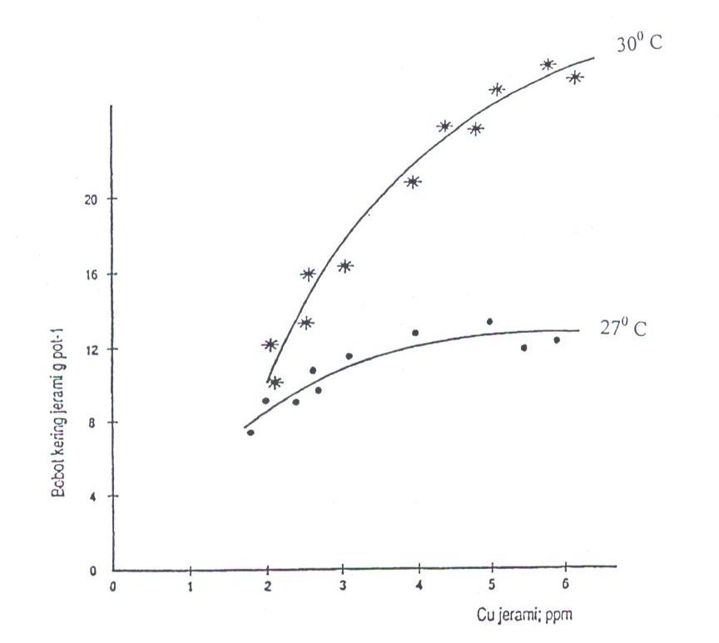

Figure IV.1 The relationship between dried weight straw and Cu straw wheat

plant that be planted at two experimental temperature for 6 weeks.

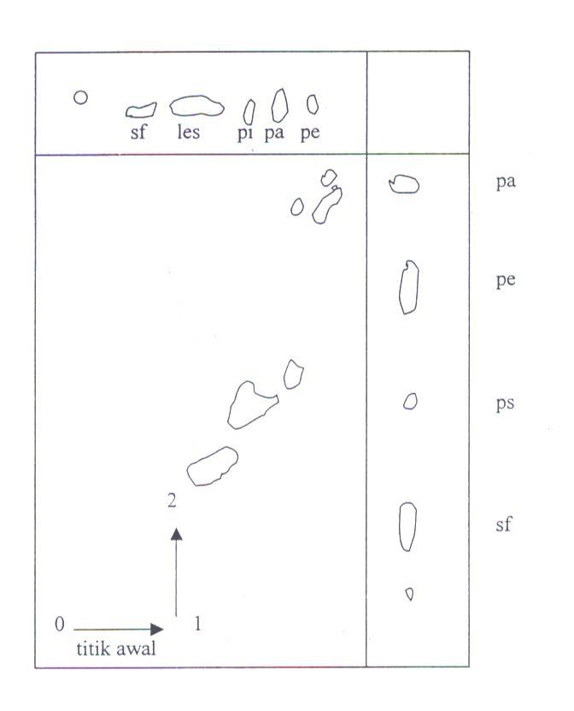

Figure IV.2 The separation of two dimensions of phospholipid essence from human erythrocytes. Solvent: chloroform – metanol – light oil – wáter (8: 8: 6: 1) in the first dimensión and aceton – chloroform – metanol – wáter (8: 6: 2: 2: 1) in the second dimensión (Last name of autor, Year).

These are examples of abbreviations writing in thesis. These are some of abbreviations that included in the abbreviations and symbols list e.g. High Performance Liquid Chromatography (HPLC), Nuclear Magnetic Resonance (NMR), and Polymerase Chain Reaction (PCR).

Chapter V Summary and Conclusion

This section provides a summary and conclusion of the study (Chapters I to V). Please ensure that the (practical) implications of the findings to the relevant stakeholders (literature, business, government, and society) and future research are provided.

REFERENCES

Davenport, T. H. (1998): Putting the enterprise into the enterprise system, *Harvard Business Review*, **July-August 1998**, 1-11.

Eisenhardt, K. M. (1989): Building theories from case study research, *The Academy of Management Review.* **14** (4), 532-550.

Hasan, M. M., and Habib, A. (2017): Firm life cycle and idiosyncratic volatility, *International Review of Financial Analysis,* **50**, 164-175.

Karniouchina, E. V., Carson, S. J., Short, J. C., and Ketchen Jr, D. J. (2013): Extending the firm vs. industry debate: does industry life cycle stage matter?, *Strategic Management Journal*, **34**, 1010–1018.

Li, M., Cao, X. J., Wang, L., Deng, L. (2016): The product-service lifecycle management based on sustainable development, *Service Operations and Logistics, and Informatics (SOLI), 2016 IEEE International Conference on The Product-service Lifecycle Management Based on Sustainable Development IEEE Xplore Document*, 200-205.

Maijanen-Kylaheiko, P. (2014): Pursuit of change versus organizational inertia: a study on strategic renewal in the Finnish broadcasting company, Masters’ Program Thesis, Lappeenranta University of Technology, 50-59

Stark, H. (1998): The dynamics of surface adsorption, *Proceedings of the International Congress on Current Aspects of Quantum Chemistry,* London, U.K., Carbo R., ed., Prentice Hall, 24 – 36.

Sundin, E. (2009): Life-Cycle Perspectives of Product/Service-Systems: In Design Theory, 31-49 in Sakao, T. and Lindahl, M., ed., *Introduction* *to Product/Service-System Design*, Springer-Verlag, London.

Swanson, R. A., and Chermack, T. J. (2013): *Theory Building in Applied Disciplines*, Berret-Koehler Publishers Inc., San Francisco, 112-117.

Vargo, S. L., Maglio, P. P., and Akaka, M. A. (2008a): On value and value co-creation: service systems and service logic perspective, *European Management Journal*, **26**, 145– 152.

Vargo, S. L., and Lusch, R. F. (2008b): From goods to service(s): Divergences and convergences of logics, *Industrial Marketing Management,* **37**, 254–259.

**References from Newspaper:**

Article title. (Date). *Newspaper Name*, page. XX.

Informant (Date). Article title. *Newspaper Name*, page. YY.

Pengelolaan diusulkan satu lembaga. (16 Oktober 2015). *Kompas*, hal. 14.

Saidi, A. I. (16 Oktober 2015). Semiotika laut. *Kompas*, hal. 6.

**References from Film or Television:**

Figure Name (The Position of the Figure). (Date). *Event Name* [Event type]. Television Station Name/ Film Producer: City

Sagantoro, A. (Producer). (2011). *The Raid* [Life Image]. PT. Merantau Films and XYZ Films: Jakarta.

Arlusi, R. and Ginting E. (Executive Producer). (21 Oktober 2015). *Mata Najwa* [Television broadcast]. Metro TV: Jakarta.

**References from website:**

Data Air Mampu Curah periode 1950 – 2000 is a grid data (reanalysis) from *National Centre for Environmental Prediction* (NCEP), data is obtained from website: http://www.esrl.noaa.gov/psd/data/gridded/data .ncep.reanalys2.html. Downloaded on May 5, 2013.

Data Indeks DM periode 1901 – 2000 the result of reanalysis from *Japan Agency for Marine Earth Science and Technology* (JAMSTEC), data is obtained from website: http:/www.jamstec.go.jp/frcgc/research/d1/iod/kaplan_sst_dmi_new.txt. Downloaded on Oktober 28, 2013.

Peta Pola Suhu Permukaan Laut (SPL) di Samudra India Ekuatorial, data is obtained from website: http://www.jamstec.go.jp/frsgc/research/d1/iod/. Downloaded on Agustus 2, 2012.

Note:

1. Types of references writing formats are as follow:

First reference is **magazine** written by single authors.

Second reference is **journal** written by single author.

Third reference is **journal** written by 2 authors.

Fourth reference is **journal** written by more than 2 authors.

Fifth reference is reference publish through **conference**.

Sixth reference is masters’ program **thesis**.

Seventh reference is **proceeding**.

Eighth reference is **book** that each chapter written by different authors and there is editor/s.

Ninth reference is **book**.

Tenth and eleventh references are references written by the same main author but published at different time.

1. Additional criteria regarding appropriateness for inclusion in the references follows the prevalence in each discipline of science and is governed by the KPPs-Faculties.
2. It is not allowed to cite from **newspaper**, **radio** or **TV** unless it is used as research object. The references form website is also written in alphabetically order, not necessarily numbered.
3. If any master program thesis used as reference, the format is as shown by the eleventh reference.
4. This section lists all references that have been cited in the document in alphabetical order. Please follow a citation/reference style as required by ITB. To make this easier, you may use Endnote, Mendeley or other bibliography management software to organise the citation/references.

APPENDICES

This section shows all appendices that support the discussion in the thesis. Please mention each appendix in the thesis to link them to the content.

Appendix A Example of Approval Page Contains Two Supervisors

THESIS TITLE; FONT; TIMES NEW ROMAN; CAPITAL LETTER; 14; BOLD; SINGLE SPACE

By

Student Name

Student ID: 2900001

(Masters’ Program of Science in Management)

Institut Teknologi Bandung

Approved

Supervisor Team

Date ............................(date month year)

Supervisor

______________________

(Name of Supervisor)

Appendix B Example of Writing Appendix Titles

|  |  |  |  |  |  |
| --- | --- | --- | --- | --- | --- |
| Example table with length that exceeds the page limit | | | | | |
|  |  |  |  |  |  |
|  |  |  |  |  |  |
|  |  |  |  |  |  |
|  |  |  |  |  |  |
|  |  |  |  |  |  |
|  |  |  |  |  |  |
|  |  |  |  |  |  |
|  |  |  |  |  |  |
|  |  |  |  |  |  |
|  |  |  |  |  |  |
|  |  |  |  |  |  |
|  |  |  |  |  |  |
|  |  |  |  |  |  |
|  |  |  |  |  |  |
|  |  |  |  |  |  |

Appendix B Example of Writing Appendix Titles (continuance)

|  |  |  |  |  |  |
| --- | --- | --- | --- | --- | --- |
| Example table with length that exceeds the page limit | | | | | |
|  |  |  |  |  |  |
|  |  |  |  |  |  |
|  |  |  |  |  |  |
|  |  |  |  |  |  |
|  |  |  |  |  |  |
|  |  |  |  |  |  |
|  |  |  |  |  |  |
|  |  |  |  |  |  |
|  |  |  |  |  |  |

Appendix C Please Write the Title of the Appendix

C1. Please Write the Title of the Sub Appendix

Write a new paragraph here by adding 1 line single space. Each new paragraph should consist of several sentences.

C2. Please Write the Title of the Sub Appendix

Write a new paragraph here by adding 1 line single space. Each new paragraph should consist of several sentences.

Note: The Appendix may consist of several pieces. The appendix may contain additional notes; formula derivation; calculation examples; raw research data; etc., which, if incorporated into the body of the thesis will interfere the explanation smoothness in the body of thesis. Each appendix is numbered in the capital letters of the Latin alphabets A, B, C, ... and so on. The appendix is preceded by a page containing only the word APPENDICES (size 14, bold) in the middle of the page and given the page number. The appendix can be tables, figures, and so on which (is considered) not a major part of the thesis. The appendix MUST be referred in the thesis body with the format e.g. "Appendix A".

Appendix D Example of Margin for Odd Pages (if the thesis Document is Printed Both Sides)

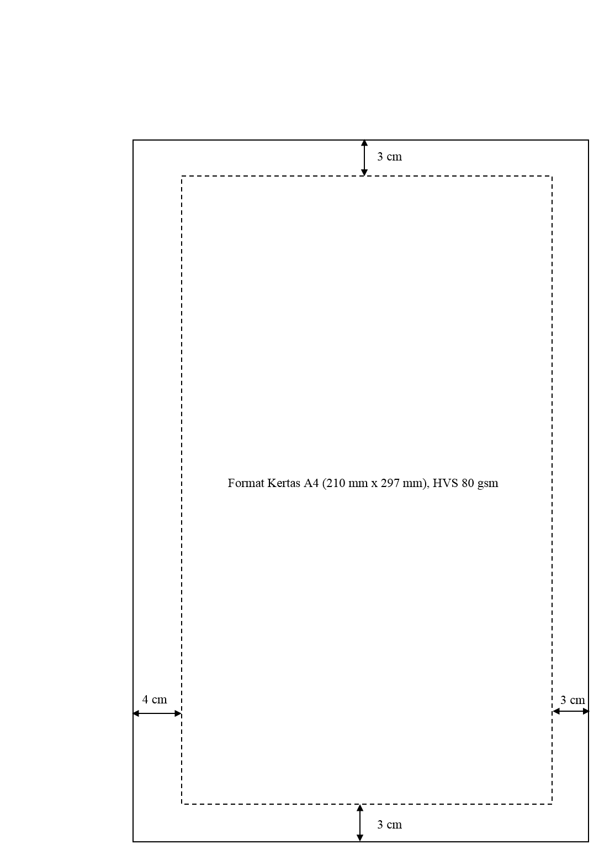

Note: The above illustration is not an actual measure. Author can use thicker paper if needed, for example: if a printout looms into the back of the paper.

Appendix E Example of Margin for Even Pages (if the Thesis Document is Printed on Both Sides)

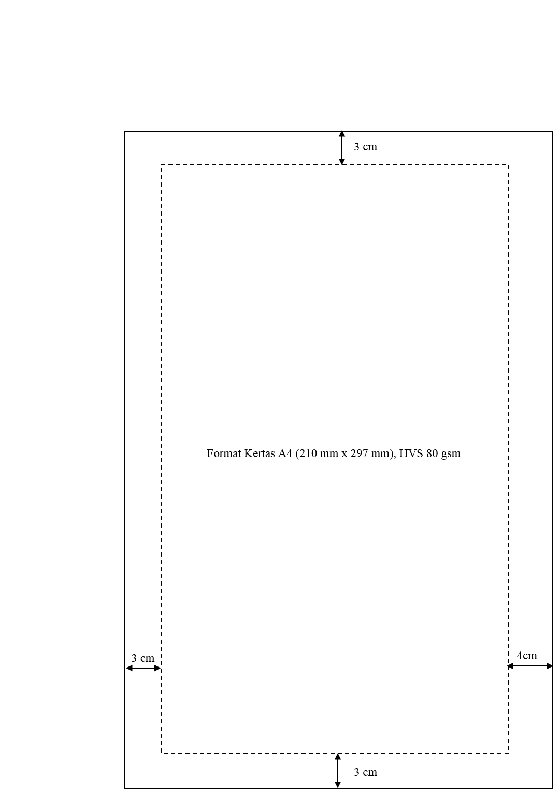

Note: The above illustration is not an actual measure

Appendix F Example of Thesis Cover and Binding

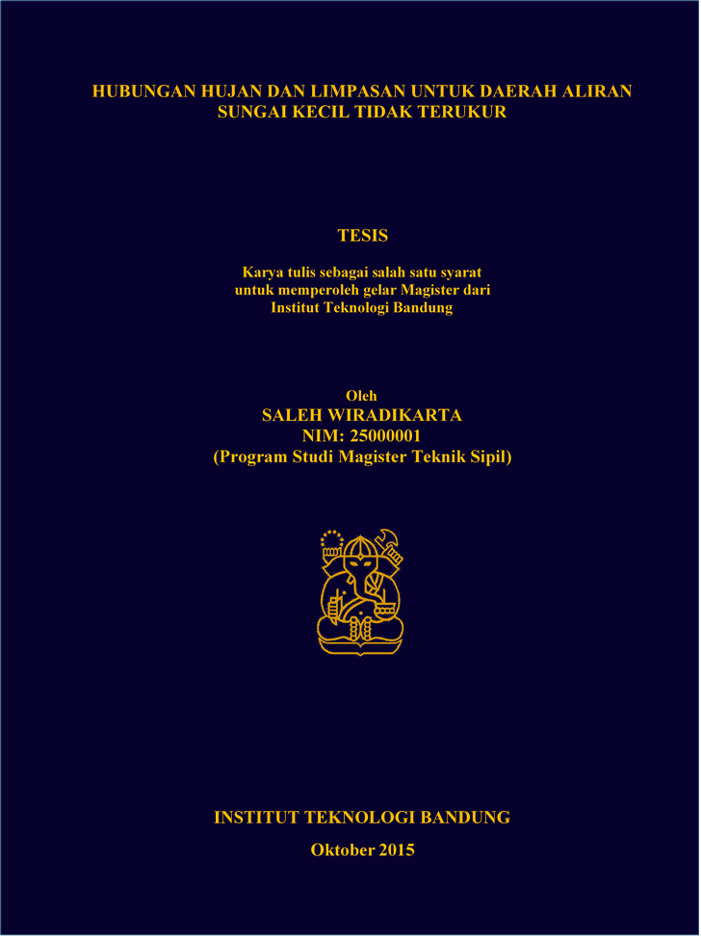

Catatan:

1. The final thesis script should be bound by hard cover, Dark Blue (Biru Dongker), Omega No.10 paper type, and the writing on the cover is printed with gold ink.

2. Author name, Studnet Number, Thesis Title, ITB logo, month and year should be written on the side part of the cover. The name of month (January – December) on the side part of the cover should be abbreviated as: Jan, Feb, Mar, Apr, Mei, Jun, Jul, Ags, Sep, Okt, Nov, dan Des.